**ITS 26000 – Applied Database Tech**

**Lab 10 – (100 points)**

**Reload the tables again (Run the database scripts) before doing this exercise.**

**Use SQL to complete the following exercises.**

### **KimTay Pet Supplies:**

1. Create a view named MAJOR_CUSTOMER. It consists of the customer ID, first name, last name, balance, credit limit, and rep ID for every customer whose credit limit is $500 or less. (25 points)
   1. Write and execute the CREATE VIEW command to create the MAJOR_CUSTOMER view.

create view major_customer as

select cust_id,

first_name,

last_name,

balance,

credit_limit,

rep_id

from customer

where credit_limit <= 500;

* 1. Write and execute the command to retrieve the customer ID, first name, and last name of each customer in the MAJOR_CUSTOMER view with a balance that exceeds the credit limit.

select cust_id, first_name, last_name

from major_customer

where balance > credit_limit;

* 1. Write and execute the query that the DBMS actually executes.

select cust_id, first_name, last_name

from (select cust_id,

first_name,

last_name,

balance,

credit_limit,

rep_id

from customer

where credit_limit <= 500) as A

where balance > credit_limit;

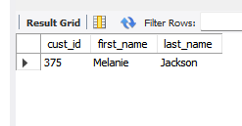

* 1. Does updating the database through this view create any problems? If so, what are they? If not, why not? (10 points)

No, it will not cause any problems because it doesn’t have any aggregate functions, joins or group by statements

1. Create a view named ITEM_INVOICE. It consists of the item ID, description, price, invoice number, invoice date, number ordered, and quoted price for all invoice lines currently on file. (25 points)
   1. Write and execute the CREATE VIEW command to create the ITEM_INVOICE view

Create view item_invoice as

select item.item_id,

item.description,

price,

invoices.invoice_num,

invoice_date,

quantity,

quoted_price

from item, invoice_line, invoices

where item.item_id = invoice_line.item_id and invoice_line.invoice_num = invoices.INVOICE_num;

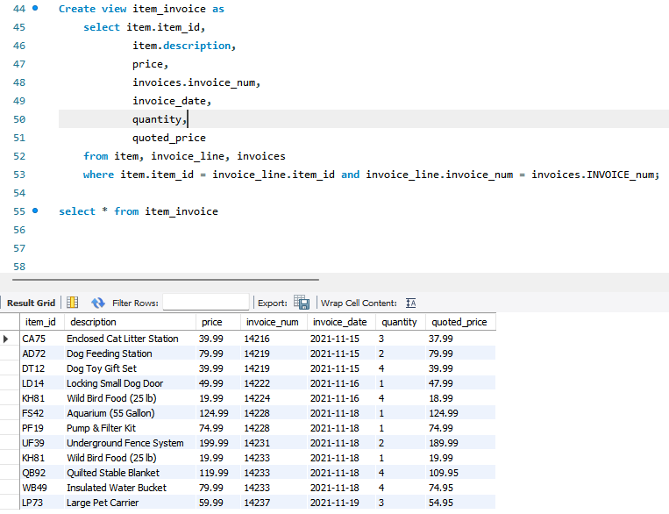

* 1. Write and execute the command to retrieve the item ID, description, invoice number, and quoted price for all invoices in the ITEM_INVOICE view for items with quoted prices that exceed $100.

select item_id, description, invoice_num, quoted_price

from item_invoice

where quoted_price > 100;

* 1. Write and execute the query that the DBMS actually executes.

select item_id, description, invoice_num, quoted_price

from (select item.item_id,

item.description,

price,

invoices.invoice_num,

invoice_date,

quantity,

quoted_price

from item, invoice_line, invoices

where item.item_id = invoice_line.item_id and invoice_line.invoice_num = invoices.INVOICE_num) as A

where quoted_price > 100;

* 1. Does updating the database through this view create any problems? If so, what are they? If not, why not?

It depends on what you are updating. If you are updating information that is in only one table then it does not create any problems, however if you want to update information in multiple tables it will create problems.

### **StayWell Student Accommodation:**

1. Create a view named PROPERTY_OWNERS. It consists of the property ID, office number, square footage, bedrooms, floors, monthly rent, and owner’s last name for every property in which the number of bedrooms is three. (25 points)
   1. Write and execute the CREATE VIEW command to create the PROPERTY_OWNERS view.

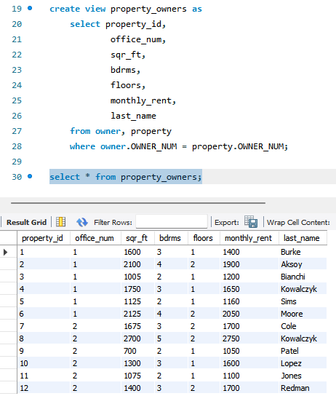

create view property_owners as

select property_id,

office_num,

sqr_ft,

bdrms,

floors,

monthly_rent,

last_name

from owner, property

where owner.OWNER_NUM = property.OWNER_NUM;

* 1. Write and execute the command to retrieve the property ID, office number, monthly rent, square footage, and owner’s last name for every property in the PROPERTY_OWNERS view with a monthly rent of less than $1675.

select property_id, office_num, monthly_rent, sqr_ft, last_name

from property_owners

where monthly_rent < 1675;

* 1. Write and execute the query that the DBMS actually executes.

select property_id, office_num, monthly_rent, sqr_ft, last_name

from (select property_id,

office_num,

sqr_ft,

bdrms,

floors,

monthly_rent,

last_name

from owner, property

where owner.OWNER_NUM = property.OWNER_NUM) as A

where monthly_rent < 1675;

* 1. Does updating the database through this view create any problems? If so, what are they? If not, why not?

It depends on what you are updating. If you are updating information that is in only one table then it does not create any problems, however if you want to update information in multiple tables it will create problems.

1. Create a view named MONTHLY_RENTS. It consists of two columns: The first is the number of bedrooms, and the second is the average monthly rent for all properties in the PROPERTY table that have that number of bedrooms. Use AVERAGE_RENT as the column name for the average monthly rent. Group and order the rows by number of bedrooms. (25 points)
   1. Write and execute the CREATE VIEW command to create the MONTHLY_RENTS view.

create view monthly_rents as

select bdrms, avg(monthly_rent) as average_rent

from property

group by bdrms

order by bdrms;

* 1. Write and execute the command to retrieve the bedrooms and average fee for each bedrooms for which the average fee is greater than $1,100.

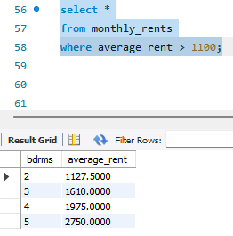

select *

from monthly_rents

where average_rent > 1100;

* 1. Write and execute the query that the DBMS actually executes.

select *

from (select bdrms, avg(monthly_rent) as average_rent

from property

group by bdrms

order by bdrms) as a

where average_rent > 1100;

* 1. Does updating the database through this view create any problems? If so, what are they? If not, why not?

Yes, it does create problems because it has the group by function.

**Deliverables**: **Document Report with the SQL statement/Query and snapshot of query, its execution and results.** Either word or pdf file need to be uploaded into Brightspace in one submission